**Green Society Public School**

**Ratnanagar-7, Sauraha, Chitwan**

**Second Terminal Examination-2082**

**Class: Nursery Time: - 2 hrs. F.M.: 50**

**Sub: Rhy. & Conv.**

1. What is your name? [5]
2. How are you? [5]
3. In which class do you read? [5]
4. Identify these pictures? [5]

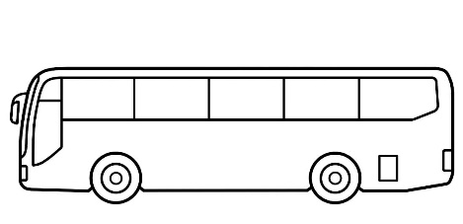

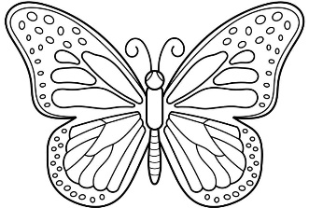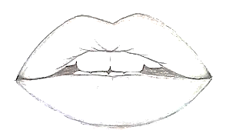

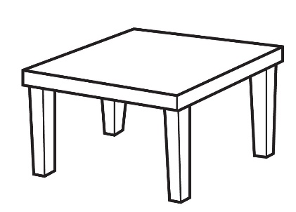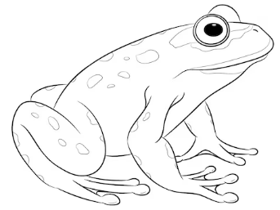

1. Rhymes. [5]
2. Dance. [5]
3. Neat and clean. [10]
4. Regularity. [10]

**The End**